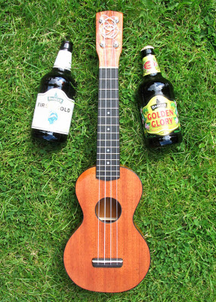
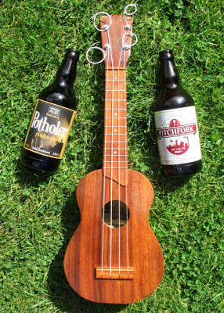
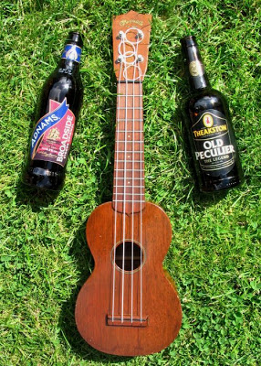
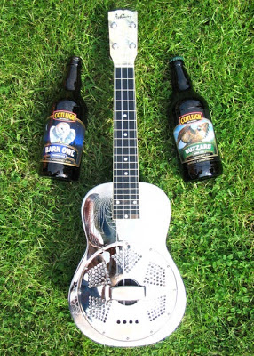
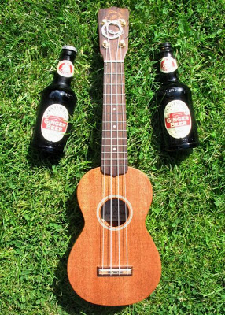
Scarborough Uke Jam
Beerfest Songbook
Old Stone Cottage
June 20, 2015
Ukulele Boogie

C
I don't care if your dog has fleas
G
A newb or a pro or in-between
F
All you need are these four strings
G7 C
Now you're really ready to swing

chorus
F
Ukulele boogie
C
It's the ukulele boogie
G
The ukulele boogie is about to begin
G7 C
Grab a uke, you can join on in

F
Give an "F" to the folks who don't understand
C
See, you're playing with the band
G
Gee, I could just play all day
G7 C
'Til seven, and I'm on my way

C 0003
F 2010
G7 0212
C
That boogie will not let you down
G
Soon you'll be doing it all over town
F
Playing that uke for miles and miles
G7 C
People just gotta smile

chorus

harmonica solo (tab for standard 10-hole C major diatonic)
F
C 0003
F 2010
G7 0212
6 -5 5 4 6 -5 4
C
4 5 6 7 7 7 -7 7 7
G C
-5 5 -5 5 -5 5 -5 5 4

C
Gotta let that boogie flow
G
Rhythm will not let you go
F
Boogie over here and boogie over there
G7 C
Ukuleles everywhere

chorus x 2

G7 C
'Til seven, and I'm on my way
G7 C!
'Til seven, and I'm on my way!m

C! C!

C6 arpeg.(My dog has fleas) on

Intro
Don’t Worry Be Happy
C 0003
Dm 2210
F 2010
|C | |
7 -6 6 -6 5 6 5 -4
|Dm | |
4 -4 5 -4 6 5 -4 |
F | |
4 -4 5 -4 5 -4 4-4
|C | |
4
|C | |
Here’s a little song I wrote, you
|Dm | |
might want to sing it note for note Don't
|F | |
worry be
|C | |
happy
||C | |
In every life we have some trouble
|Dm | |
When you worry you make it double Don’t
|F | |
worry be
|C | |
happy Don’t worry, be happy now
Chorus
||:C | |
7 -6 6 -6 5 6 5 -4
|Dm | |
4 -4 5 -4 (Don’t Worry) 6 5 -4 |
F | |
4 -4 5 -4 (Be happy) 5 -4 4-4
|C | :|| 2x
4 Don’t worry, be happy now
Verse 2
|C | |
Ain't got no place to lay your head
|Dm | |
Somebody came and took your bed Don’t
|F | |
worry be
|C | |
happy The
|C | |
land lord say your rent is late
|Dm | |
He may have to litigate Don’t
|F | |
worry be
|C | |
happy Don’t worry, be happy now
Verse 3
C 0003
Dm 2210
F 2010
|C | |
Ain't got no cash ain’t got no style
|Dm | |
Ain’t got no gal to make you smile Don’t
|F | |
worry be
|C | |
happy ‘Cuz
|C | |
when you worry your face will frown and
|Dm | |
That will bring everybody down Don’t
|F | |
worry be
|C | |
happy Don’t worry, be happy now
D | |A | || 2x
|D | |A | ||4x
Summer of ‘69
D
I got my first real four-string
A
Bought it at the five-and-dime
D
D 2220
A 2199
Bm7 2222
G 0232
F 2010
Bb 3211
Played 'til my fingers bled
A
It was summer of '69
D
Me and some guys from school
A
Had a Band and we tried real hard
D
Jimmy quit and Jody got married
A
I shoulda known we'd never get far
Bm A
Oh when I look back now

D G
That was summer seemed to last forever
Bm A
And if I had the choice
D G
Ya - I'd always wanna be there
Bm A!
Those were the best days of my life
|D | |A | || 2x
D
Ain't no use in complainin'
A
When you got a job to do
D
Spent my evenin's down at the drive in
A
And that's when I met you, yeah!
Bm A
Standin on your mama's porch

D G
You told me that you'd wait forever
Bm A
Oh and when you held my hand
D G
I knew that it was now or never
Bm A!
Those were the best days of my life
D A D A
(Oh yeah)Back in the summer of 69’uh-huh
F Bb
D 2220
A 2199
Bm7 2222
G 0232
F 2010
Bb 3211
Man we were killin' time
C
We were young and restless
Bb
We needed to unwind
F Bb C
I guess nothin' can last forever, forever no
|D | |A | || 2x
D
And now the times are changin'
A
Look at everything that's come and gone
D
Sometimes when I play that old four-string
A
I think about ya wonder what went wrong
Bm A
Standin on your mama's porch
D G
You told me that it’d last forever
Bm A
Oh and when you held my hand
D G
I knew that it was now or never
Bm A!
Those were the best days of my life
D A D A
(Oh yeah)Back in the summer of 69’uh-huh
D A D A
(Oh yeah)Back in the summer of 69’uh-huh
|D | |A | || repeat and fade

|D |C |G | || 4x
Sweet Home Alabama
D C G G
D 2225
C 0003
G 0232
F 2010
Big wheels keep on turning
D C G G
Carry me home to see my kin
D C G G
Singing songs about the south land
Chorus
|D |C |G | C! |
Sweet home Alabama,
|D |C |G | |
where the skies are so blue
|D |C |G | C! |
Sweet home Alabama,
|D |C |G |F! C! ||
lord I’m coming home to you.

D C G G

I miss Alabamy Once Again and i think its a sin
|D |C |G | || 4x
D C G G
Well I heard Mr. Young sing about her
D C G G
Well I heard old Neil put her down
D C G G
Well I hope Neil Young will remember
D C G G
A southern man don’t need him around, anyhow
D C G F! C! D
In Birmingham they loved the governor, (booh ooh ooh)
D 2225
C 0003
G 0232
F 2010
(D) C G G
Now we all did what we could do
D C G G
Now watergate does not bother me
D C G G
Does you conscience bother you, (now tell the truth!)
Chorus/solo/chorus

D C G G
Now Muscle Shoals has got the Swappers
D C G G
And they've been known to pick a song or two
D C G G
Lord they get me off so much
D C G G
They pick me up when I'm feeling blue Now how about you? Chorus/solo end on D!

Intro
Don’t Stop Believing
C 0003
G 0232
Am 2000
F 2010
Em7 0202
C G Am F
C G Em7 F

C G Am F
Just a small town girl, living in a lonely world
C G Em7 F
She took the midnight train going anywhere
C G Am F
Just a city boy, born and raised in south Detroit
C G Em7 F
He took the midnight train going anywhere C G Am F
A singer in a smoky room, a smell of wine and cheap perfume
C G Em7 F
For a smile they can share the night, it goes on and on and on and on

|F | |C | |
Strangers waiting up and down the boulevard
F C
Their shadows searching in the night
F C
Streetlight, people, living just to find emotion
F |G | |
Hiding, somewhere in the night

C G Am F
Working hard to get my fill, everybody wants a thrill
C G Em7 F
Paying anything to roll the dice, just one more time
C G Am F
Some will win, some will lose, some were born to sing the blues
C G Em7 F
Oh, the movie never ends; it goes on and on and on and on
|F | |C | |
Strangers waiting up and down the boulevard
F C
Their shadows searching in the night
F C
Streetlight, people, living just to find emotion
F |G | |
Hiding, somewhere in the night
C G Am F
Don't stop believing hold on to the feeling
C G Em7 F
Streetlight people

C G Am F
Don't stop believing hold on to the feeling
C G Em7
Streetlight people
C G Am F
Don't stop believing hold on to the feeling
C G Em7 F
Streetlight people, oh oh oooooooooh!
C!
Don’t Stop!
C 0003
G 0232
Am 2000
F 2010
Em7 0202

|:F C/E |Dm7 C :|x4
59th Street Bridge
(Feelin’ Groovy)
F C/E Dm7 C
Slow down, you move too fast.
F C/E Dm7 C
You got to make the morning last. Just
F C/E Dm7 C
kickin’ down the cobble stones -
F C/E Dm7 C
lookin’ for fun, and feelin' groovy.
|F C/E |Dm7 C |
Ba-da-da
F C/E Dm7 C
da da da da feelin’ groovy

|F C/E |Dm7 C |

F C/E Dm7 C
Hello lamppost, whatcha knowin’?
F C/E Dm7 C
I Come to watch your flowers growing.
F C/E Dm7 C
Ain'tcha' got no rhymes for me?
F C/E Dm7 C
Doot’n doo doo, feelin' groovy.
|F C/E |Dm7 C |
Ba-da-da
F C/E Dm7 C
da da da da feelin’ groovy

|F C/E |Dm7 C |

F 2013
C 0003
Dm7 2213

F C/E Dm7 C
I got no deeds to do, no promises to keep.
F C/E
I'm dappled and drowsy and
Dm7 C
ready to sleep. Let the
F C/E
morning time drop all its
Dm7 C
petals on me.
F C/E Dm7 C
life, I love you, all is groovy.
| F C/E |Dm7 C |
Ba da da
|:F C/E | Dm7 C :|
F 2013
C 0003
Dm7 2213
da da da da

A
Three Little Birds
Don't worry, about a thing
D A
Cause' every little thing, gonna be alright
A
Singin' don't worry, about a thing
D A
Cause' every little thing, gonna be alright
A
Rise up this mornin‘
E7
Smile with the rising sun
A D
three little birds perch by my doorstep
A
A 2100
D 2220
E7 1202
Singin' sweet songs
E7
of melodies pure and true
D A
sayin', this my message to you-oo-oo
Intro
Bye Bye Love
|A!X X X |X X C5! D7sus4!
|A!X X X |X X C5! D7sus4!|
CHORUS
D A
A 2100
C5 0033
D7sus4 0055
D 2220
E7 1202
BYE BYE LOVE
D A
BYE BYE HAPPINESS
D A
HELLO LONELINESS
E7 A
I THINK I'M-A GONNA CRY-Y

D A
BYE BYE LOVE
D A
BYE BYE SWEET CARESS
D A
HELLO EMPTINESS
E7 A
I FEEL LIKE I COULD DIE-E
E7 |A / / /| A!
BYE BYE MY LOVE GOODBY-EYE

VERSE 1
N.C E7 A
THERE GOES MY BABY WITH SOMEONE NEW
E7 A A7
SHE SURE LOOKS HAPPY, I SURE AM BLUE
D E7
SHE WAS MY BABY TILL HE STEPPED IN
|A |A! |
GOODBYE TO ROMANCE THAT MIGHT HAVE BEEN
Chorus

A 2100
C5 0033
D7sus4 0055
D 2220
E7 1202

VERSE 2
N.C E7
I'M THROUGH WITH ROMANCE
A
I'M THROUGH WITH LOVE
E7 A A7
I'M THROUGH WITH COUNTIN' THE STARS ABOVE.
D E7
AND HERE THE REASON THAT I'M SO FREE
|A |A! |
MY LOVIN' BABY IS A THROUGH WITH ME
Chorus
|A!X X X |X X C5! D7sus4! |A!X X X |X X C5! D7sus4!| A!
|C |Dm |Em7 |Dm |C |G7 ||
Come Sail Away
C 0003
Dm 2210
Em7 0202
Am 2000
G7 0212
F 2010
Am7 0000

C Em7 Am Am7
I'm sailing away,
F G
set an open course for the virgin sea
C Em7 Am Am7
'Cause I've got to be free,
F G
free to face the life that's ahead of me
Am G
On board I'm the captain, so climb aboard
Am G
We'll search for tomorrow, on every shore
C G Am Am7
And I'll try, oh Lord, I'll try,
F G
to carry on
|C |Dm |Em7 |Dm |C |G7 ||
C Em7 Am Am7
I look to the sea,
F G
reflections in the waves spark my memory
C Em7 Am Am7
Some happy, some sad,
F G
I think of childhood friends, and the
dreams we had
Am G
We lived happily forever, so the story goes
Am G
But somehow we missed out, on the pot of gold
C G Am Am7
But we'll try, best that we can,
F G
to carry on
|C |F |G |F |
C 0003
Dm 2210
Em7 0202
Am 2000
G7 0212
F 2010
Am7 0000
|C |F |G |F ||
C F
A gathering of angels,
G F
appeared above my head
C F
They sang to me this song of hope,
G F
and this is what they said, they said

Chorus
C F
Come sail away, come sail away,
G F
come sail away with me, lads
C F
Come sail away, come sail away,
G F
come sail away with me
C F G
I thought that they were angels, but to my
F
surprise,
C F
We climbed aboard their starship,
G F
we headed for the skies, singing
C F
Come sail away, come sail away,
G F
come sail away with me, lads
Chorus

Closing Time
||:G D |Em C :|| 4X

G D Em C
Closing time Open all the doors and
G D Em C
let you out into the world
G D Em C
Closing time Turn all of the lights on over
G D Em C
every boy and every girl
G 0232
D 2220
Em7 0202
Em 0432
C 0003

G D Em C
Closing time One last call for alcohol so
G D Em C
finish your whiskey or beer
G D Em C
Closing time You don't have to go home
G D Em C
G 0232
D 2220
Em7 0202
Em 0432
C 0003
but you can't stay here

CHORUS
G D Em C
I know who I want to take me home
I know who I want to take me home
I know who I want to take me home
Take me home

G D Em C
Closing time Time for you to go out to the
G D Em C
places you will be from
G D Em C
Closing time This room won't be open till your
G D Em C
brothers or your sisters come So

G 0232
D 2220
Em7 0202
Em 0432
C 0003

G D Em C
gather up your jackets move it to the exits I

G D Em C
hope you have found a friend
G D Em C
Closing time Every new beginning comes from
G D Em C
some other beginning's end.. Yeah

CHORUS
G D Em C
I know who I want to take me home
I know who I want to take me home
I know who I want to take me home
Take me home
G!
